ELEG 312 - Example Problems Chapter 8-3

**Example 8.5**

It is required to design the cascode current-source of Fig. 8.32 to provide a current of 100 uA and an output resistance of 500 k. Assume the availability of a 0.18-um CMOS technology for which *VDD* = 1.8 V, *Vtp* = -0.5 V, *pCox* = 90 uA/V2 and *V’A* = *-*5V/um. Use |*VOV*| = 0.3 V and determine *L* and *W/L* for each transistor, and the values of the bias voltages *VG3* and *VG4.*

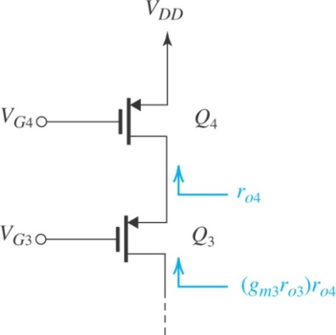given:

*VDD* = 1.8 V

*Vtp* = -0.5 V

*pCox* = 90 uA/V2

*V’A* = *-*5V/um

|*VOV*| = 0.3 V

*ID* = 100 A

*Ro* = 500 k

find:

*L* and *W/L* for each transistor

bias voltages *VG3* and *VG4.*

**Problem 8.62**

In a MOS cascode amplifier, the cascode transistor is required to raise the output resistance by a factor of 50. If the transistor is operated at *VOV* = 0.2 V, what must its *VA* be? If the process technology specifies *V’A* as 5 V/um*,* what channel length must the transistor have?

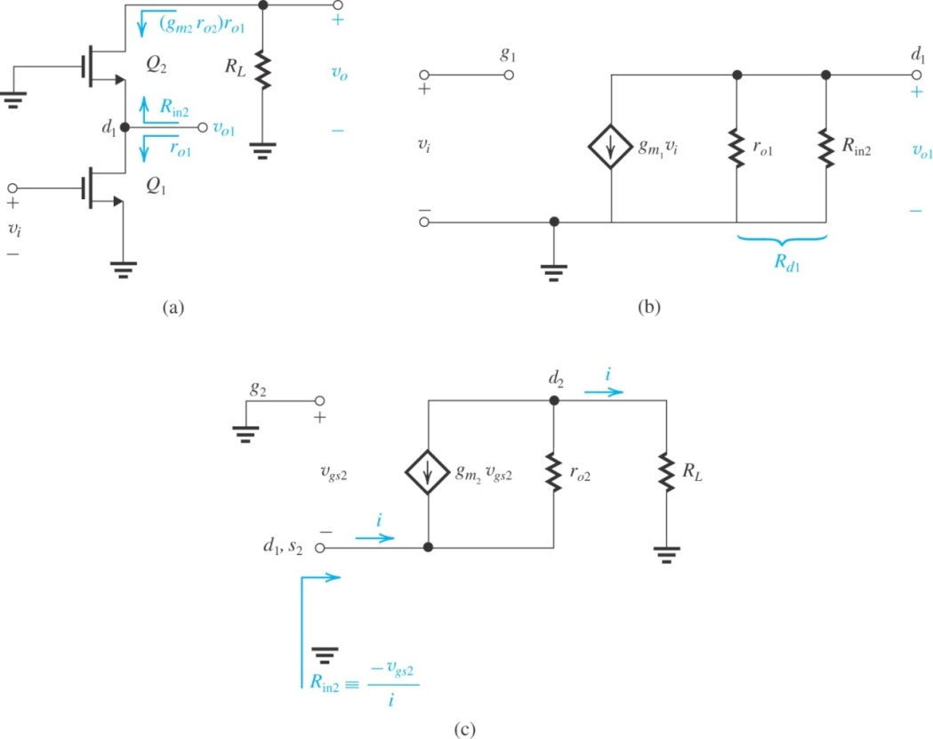

given:

$$R_{o}≈\left(g_{m2}r_{o2}\right)r_{o1}=A_{02}r_{o1}=50r_{o1}$$

*VOV* = 0.2 V

*V’A* as 5 V/um* *

**Exercise 8.24** Consider the BJT cascode amplifier of Fig. 8.38 when biased at a current of 0.2 mA. Assuming that npn transistors have *β* = 100 and *VA* = 5 V and that pnp transistors have *β* = 50 and |*VA*| = 4 V, find *Ron*, *Rop*, and *Av*. Also use the result of Exercise 8.23 to determine the maximum achievable gain.

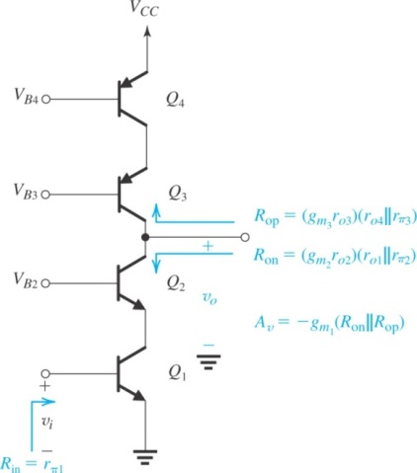

**Example 8.6**

The two circuits for generating a constant current *IO* = 10 uA shown in Fig. 8.43 operate from a 10-V supply. Determine the values of the required resistors, assuming that *VBE* is 0.7 V at a current of 1 mA and neglecting the effect of finite *.*

